1. Using input () function take one number from the user and using ternary operators check whether the number is even or odd .

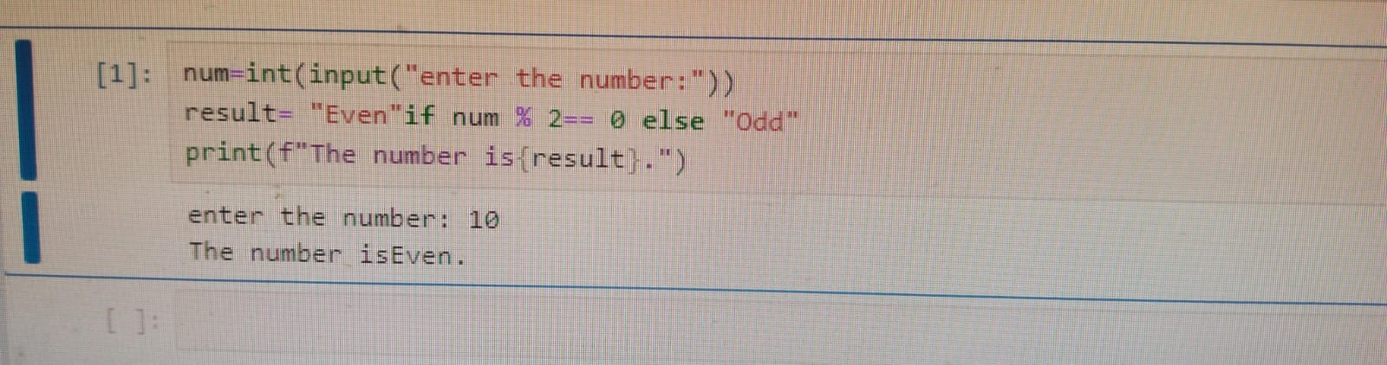

1. Using input function take two number and then swap the number .

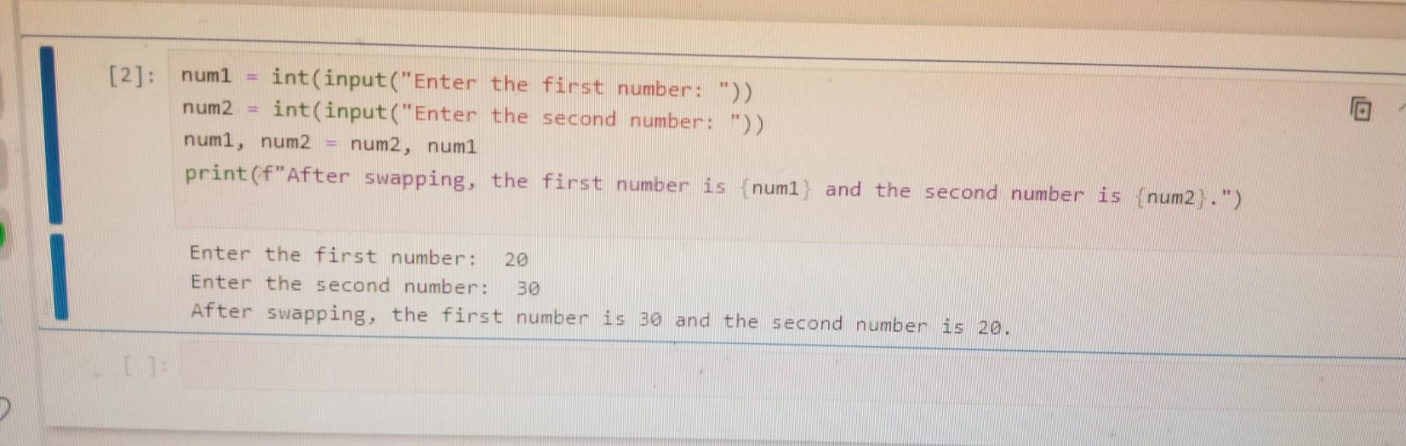

3.Write a Program to Convert Kilometers to Miles.

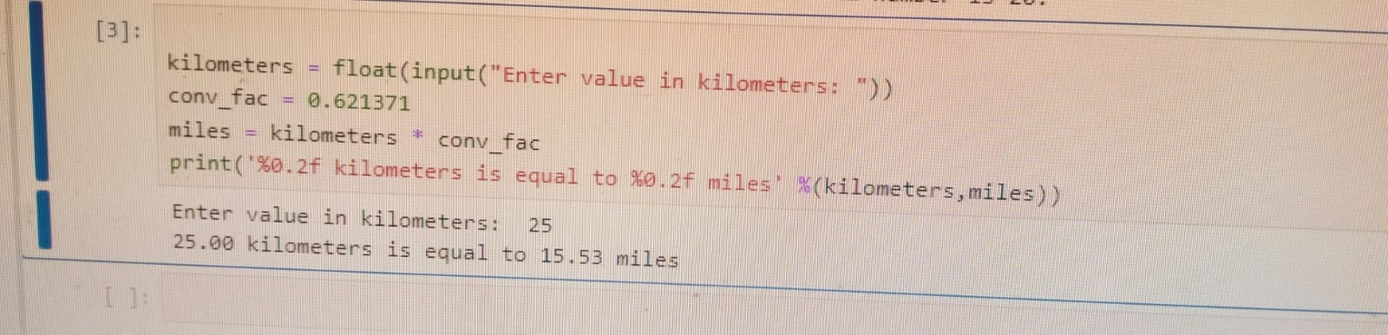

4.  Find the Simple Interest on Rs. 200 for 5 years at 5% per year.

